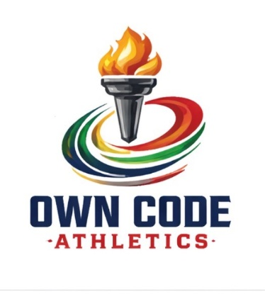

Athlete Application For Funding
Name:
Age:
Discipline:
Below Please Elaborate On Why/How OCA Backing Will Help Fuel Your Passion And Progress. This May Include Athletic Elements Or Even Pertain To Personal Growth Such As Seeking Mindset Coaching, Nutrition Consultation, Etc.

Please Use The Next Portion To Expound On Past Experience And Achievements Within Your Sport

Amount Requested (This Does Not Guarantee Any Amount Of Award):
By signing below, you acknowledge that this application does not guarantee funding and all awards are budget based. Additionally, any sum is for use in the next calendar year or the event specifically for which the application was submitted.
An Own Code Athletics sponsorship does not establish recurring financial backing. It is understood that if the athlete should not compete in the next calendar year or for any reason does not compete in the event for which funding was awarded, the athlete will return the provided sum in full to the organization by the end of the calendar year for which the award was granted.
Printed Name Of Athlete:
Signature Of Athlete & Date:
Signature,Title Of OCA Representative, & Date:

